The success of Delfs Lascelles and the quality of services we provide is dependent on the following values which underpin our company:

- A strong client focus
- Attention to detail
- Efficiency
- Communication
- Expediency
- Exceptional value

We are committed to:

- Retaining knowledge to provide best practice surveying
- Adhering to best business practices in order for the business to remain stable and viable
- Monitoring the latest surveying techniques and technologies
- Monitoring the economic environment in which we are operating
- Delivering 100% of what has been agreed with our customers
- Meeting all of our legal obligations

In order to achieve these values, we have set measurable objectives and targets that ensure we are always heading in the right direction.

Our company has implemented a management system that is continually improved, in order to help constantly refine our processes, meet our objectives, and improve our services.

To get the best outcomes for our customers, we closely monitor the needs and expectations of all interested parties, including:

- Industry Associations such as Consulting Surveyors NSW and Consulting Surveyors National
- Directors
- Employees
- Suppliers
- Government and industry regulators
- Universities and training organisations

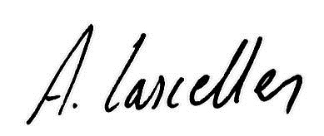
Alex Lascelles Nigel Delfs
Director Director

Date: 30/11/2017 Review by: December 2018

