Delfs Lascelles are committed to providing safe and healthy working conditions for the prevention of work-related injury and ill health.

In order to honour this commitment, we are committed to:
- Setting measurable WHS objectives and targets to ensure we are always improving our systems
- Satisfying all applicable legal and other requirements
- Controlling WHS risks by selecting controls in the following order:
  - Eliminate the hazard;
  - Substitute with less hazardous materials, processes, operations or equipment;
  - Use engineering controls;
  - Use administrative controls;
  - Provide and ensure use of adequate personal protective equipment.
- Continually improving our WHS Management System to enhance our WHS performance
- Involving Workers in decision making processes of our WHS management system

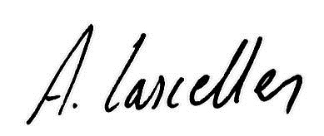
Alex Lascelles Nigel Delfs
Director Director

Date: 30/11/2017 Review by: December 2018

